 | 15.1.6 Editors - Movie Clip Editor - Header - Tracking Mode - Clip Submode - Track Menu
Table of content
Track Menu 3
Transform 3
Move 3
Last Operator Move Last 3
Move X Y Z 3
Axis Ortho 3
Orientation 3
Proportional editing 4
Proportional Falloff 4
Proportional Size 4
Connected 4
Projected(2D) 4
Resize 4
Last Operator Resize Last 4
Resize X Y Z 4
Orientation 4
Proportional editing 4
Proportional Falloff 4
Proportional Size 4
Connected 5
Projected(2D) 5
Reconstruction 5
Track Motion 5
Backwards 5
Frame Backwards 5
Forwards 5
Frame Forwards 5
Clear 5
Before 5
After 5
Track Path 5
Solution 6
Refine 6
Backwards 6
Backwards 6
Add Marker 6
Detect Features 6
Last Operator Detect Features 6
Placement 6
Whole frame 6
Inside Grease Pencil 6
Outside Grease Pencil 7
Margin 7
Threshold 7
Distance 7
Create Plane Track 7
Solve Camera Motion 7
Join Tracks 7
Copy 7
Paste 7
Copy Settings to Defaults 7
Apply default settings 8
Animation 8
Insert Keyframe 8
Delete Keyframe 8
Show/Hide 8
Show Hidden 8
Hide Selected 8
Hide Unselected 8
Last operator Hide Tracks 8
Unselected 8
Clean up 8
Clean Tracks 8
Filter Tracks 8
Delete Track 9
Delete Marker 9
Reconstruction 9
Set Origin 9
Last Operator Set Origin 9
Use Median 9
Set Floor 9
Set Wall 9
Last Operator Set Plane 9
Plane 9
Set X Axis 9
Set Y Axis 10
Last Operator Set Axis 10
Axis 10
Set Scale 10
Last Operator Set Scale 10
Distance 10
Apply Scale 10
Last operator Apply Solution Scale 10
Distance 10
3D Markers to Mesh 10
Link Empty to Track 10

Track Menu

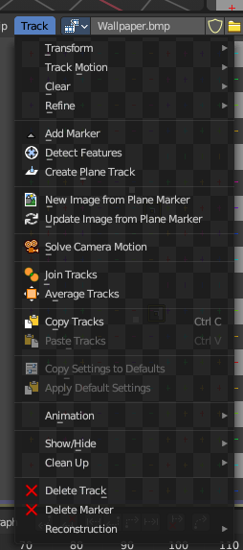
Contains tracking functionality. Note that lots of this content is currently a double entry to the content in the tool shelf. The tool shelf content will most probably vanish in the future, in favour of a tool shelf with buttons like in the 3d view.

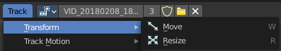
Transform
Track navigation.

Move
Move the selected track(s).

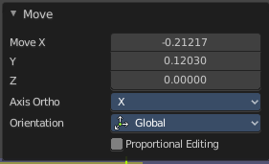
Last Operator Move Last

Move X Y Z
The transform values. Set x and y position of the track. Z value has no influence.

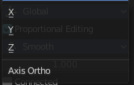
Axis Ortho
Defines the other axis of an imaginary shear axis plane.

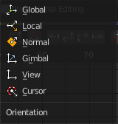
Orientation
Choose the orientation for the shear action.

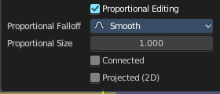
Proportional editing
Enables proportional editing. Activating proportional editing reveals further settings.

Proportional Falloff
Adjust the falloff methods.

Proportional Size
See and adjust the falloff radius.

Connected
The proportional falloff gets calculated for connected parts only.

Projected(2D)
The proportional falloff gets calculated in the screen space. Depth doesn't play a role. When it's in the radius, then it gets calculated.

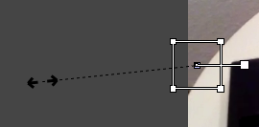
Resize
Resize the selected track(s).

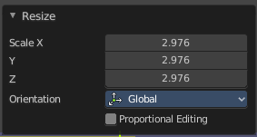
Last Operator Resize Last

Resize X Y Z
The transform values. Set x and y position of the track. Z value has no influence.

Orientation
Choose the orientation for the shear action.

Proportional editing
Enables proportional editing. Activating proportional editing reveals further settings.

Proportional Falloff
Adjust the falloff methods.

Proportional Size
See and adjust the falloff radius.

Connected
The proportional falloff gets calculated for connected parts only.

Projected(2D)
The proportional falloff gets calculated in the screen space. Depth doesn't play a role. When it's in the radius, then it gets calculated.

Reconstruction
This menu once contained nothing but double menu entries that can be found in the panels. It is part of the Blender menu structure. And a add-on may add an entry here. So it remains for compatibility reasons.

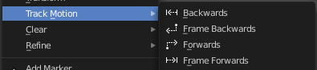
Track Motion

Backwards
Track backwards the whole range.

Frame Backwards
Track backwards frame wise.

Forwards
Track forwards the whole range.

Frame Forwards
Track forwards frame wise.

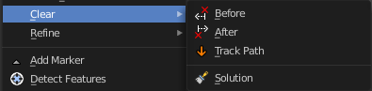
Clear

Before
Clears track paths before the current position.

After
Clears track paths after the current position.

Track Path
Clears the currently active Track Path.

Solution
Clears all calculated data.

Refine

Backwards
Refine selectet marker positions forwards.

Backwards
Refine selectet marker positions forwards.

Add Marker
Add a marker. The marker will appear under the mouse, and stick until you click.

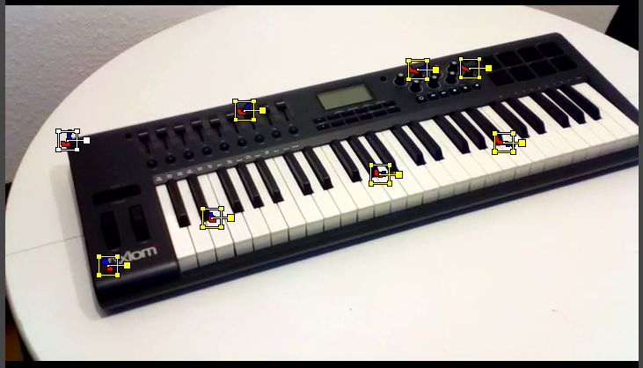
Detect Features
Adds automatically markers at the current movie position, and tries to detect marcant areas in the current frame that are useful for tracking. It also sets keyframes at this position.
When enough marcant areas are available then it adds up to eight markers that way.
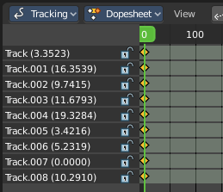

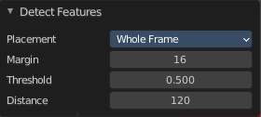
Last Operator Detect Features

Placement
Placement is a drop down box where you can limit the placement of the markers.

Whole frame
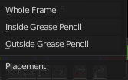
The markers can be at every position of the current frame image.

Inside Grease Pencil
The markers have to be inside the Grease Pencil.

Outside Grease Pencil
The markers have to be outside Grease Pencil.

Margin
Gives a margin to the border of the frame image. Markers have to stay away from the border by the given amount.

Threshold
The threshold level to consider the current position of the marker as good enough for tracking.

Distance
The minimum distance between two markers.

Create Plane Track
Creates a plane track. A plane track can be used to map an image or a movie at an area in your clip. The Plane track.

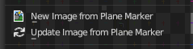
New Image from Plane Marker
Create new image from the content of the plane markerfrom the pixels of the movie clip that the plane marker “sees” at the current frame. This allows you to create and impose an un-warped texture of any flat surface in the footage.
To use, create and select four tracking points then create a Plane Marker. Once you’ve selected the Plane Marker, create the new image - then edit the image in the Image Editor.

Update Image from Plane Marker
Update current image used by plane marker from the content of the plane marker. This updates the pixels of the active Plane Track’s image.
Allows you to update the texture of any flat surface in the footage.

Solve Camera Motion
Starts the calculation for the camera motion to match the track motion.
There should be at least eight common tracks on the both of the selected keyframes.
There should be noticeable parallax effects between these two keyframes.
The average re-projection error is reported to the information space and to the clip editor header. Re-projeciton error means the average distance between reconstructed 3D position of tracks projected back to footage and original position of tracks. Re-projection error below 0.3 means accurate re-projection, (0.3 - 3.0) means quite nice solving which still can be used. Values above 3 means some tracks should be tracked more accurately, or that values for focal length or distortion coefficients were set incorrectly.

Join Tracks
Joins selected tracks.

Copy
Copy selected tracks to clipboard.

Paste
Pastes selected tracks from clipboard.

Copy Settings to Defaults
Copies track settings from active track to default settings.

Apply default settings
Copy tracking settings form active tracks to selected tracks. You need to select the source track first, then hold down shift, then select the target track. Then perform copy track settings.

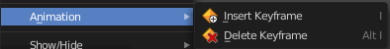
Animation

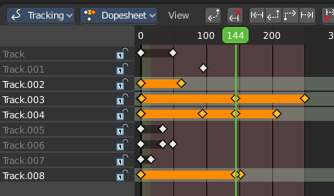
Insert Keyframe
Inserts a keyframe at current position in spreadsheet sub mode panel.

Delete Keyframe
Deletes keyframes at current position in dope sheet sub mode panel.

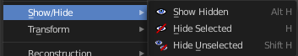
Show/Hide
Show or hide tracks.

Show Hidden
Show all hidden tracks.

Hide Selected
Hide the selected tracks.

Hide Unselected
Hide the unselected tracks.

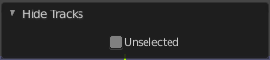
Last operator Hide Tracks

Unselected
Hide selected or unselected tracks.

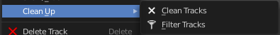
Clean up

Clean Tracks
Clean tracks with high error values or few frames.

Filter Tracks
Filter out tracks that has weird looking spikes in motion curves.

Delete Track
Delete the selected track.

Delete Marker
Delete the selected marker.

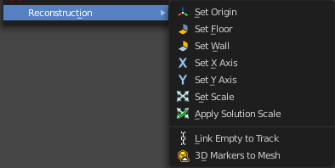
Reconstruction

Set Origin
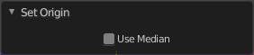
Set active marker as origin in 3D space.

Last Operator Set Origin

Use Median
Set Origin to Median Point of selected bundles.

Set Floor
Set plane in the 3D space as a Floor plane, based at three selected markers. You need to have three markers selected. Or you will get an error message.

Set Wall
Set plane in the 3D space as a Wall plane, based at three selected markers.

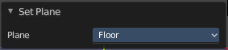
Last Operator Set Plane

Plane
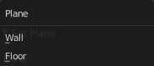
A drop down box to choose if you want to set the selected markers as plane or as floor.

Set X Axis
Set X axis rotation in 3D space, based at the selected marker. You need to have one marker selected. Or you will get an error.

Set Y Axis
Set X axis rotation in 3D space, based at the selected marker. You need to have one marker selected. Or you will get an error.

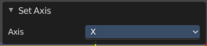
Last Operator Set Axis

Axis
A drop down box to choose if you want to use the axis to X or to Y

Set Scale
Set scale of scene by scaling camera, based at two selected markers. You need to have two markers selected. Or you will get an error.

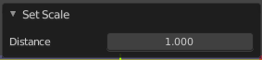
Last Operator Set Scale

Distance
The distance between two bundles used for scene scaling.

Apply Scale
Apply scale to solution.

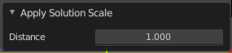
Last operator Apply Solution Scale

Distance
The distance between two bundles used for scene scaling.

3D Markers to Mesh
Creates a vertex cloud using the coordinates of the reconstructed tracks.

Link Empty to Track
Creates an Empty which will be copying movement of active track.

